Task

**Course**: Artificial Intelligence

(Machine Learning & Deep Learning)

Name: Abbas Shafi

Father Name: Dr Muhammad Shafi

Week: 02

Submitted to: Sir Syed Nazir Afridi



National Vocational & Technical Training Commission

National Center For Big Data & Cloud Computing

University of Engineering & Technology

Peshawar

**LAB NO. 1 Loops**

## Python Programming

**Introduction:**

Python programming is general purpose object oriented dynamic programming language used mainly in AI, ML, DL and data science. This language is known for their easiness and high level language. Contain large number of libraries through which programmer can easily handle tasks. **Tool used**:

* Jupyter Notebook
* Annaconda

**Task 1**: Write python program to print multiple table by for loop through user input

## Code:

n=int(input("enter number")) for i in range(1,11):

print(i," x " ,n ,"= ",i*n)

**Output:**

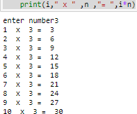

**Task 2:**Write a program to greet all the person store in list

**Code:** list=["asim","ali","rehman","khan"] greet=input("greetperson ")

for greet in list: print(greet)

**Output:**

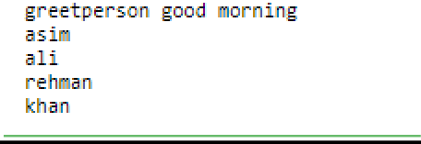

**Task 3:** Attepmt task by while loop

## Code:

**n=int(input("enter number")) i=1**

## while i<=10:

**print(i," x " ,n ,"= ",i*n) i=i+1**

**Output:**

**\** 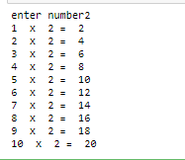

**Task 4:**Write python program to find the number is prime or not

## Code:

**#t4**

## num=int(input("enter number")) for i in range(2,num):

**if(num%i==0):**

## print(" non prime") break

**else:**

## print("prime nummber") Output:

**Task 5:** Write python program to sum number in list using loop

## Code:

#t5 sum=0

number=[2,3,10,5] for i in number:

sum=sum+i print("Sum =",sum) **Output:**

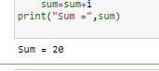

**Task 6:** Write python program to find sum of natural number ener by user

## Code:

**#t6**

## num=int(input("enter natural numbers ")) sum=0

**i=1**

## while i<=num: sum=sum+i i=i+1

**print(sum) Output:**

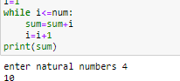

**Conclusion:**

In this lab we learned basic of loops operation of python programming and how to implement them. All the tasks were performed and submitted to the instructor.

# LAB NO. 2 Conditional Statement

**Task 1**: Write a program to find greatest of 4 number entered by user.

## Code:

n1=int(input(" enter num1 ")) n2=int(input(" enter num 2 ")) n3=int(input(" enter num3 "))

n4=int(input(" enter num4 ")) if(n1>n2 and n1>n3 and n1>n4):

print(n1,"n1 is greater") elif(n2>n3 and n2>n4 and n2>n1):

print(n2,"n2 is greater") elif(n3>n4 and n3>n2 and n3>n1):

print(n3,"n3 is greater") else:

print(n4,"n4 is greatest") print("done")

**Output:**

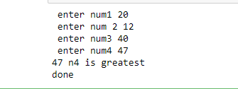

**Task 2:**Write a program to find out whether a student is pass or fail if it required atleast 40% and 33 at each subject and take the marks enter from user.

### Code:

sub1=int(input("enter sub1 ")) sub2=int(input("enter sub2 ")) sub3=int(input("enter sub3 ")) marks=((sub1+sub2+sub3)*100)/300 print("marks= ",marks,"%")

if(sub1>=33 and sub2>=33 and sub3>=33 or marks>=40): print("student pass")

else:

print("fail")

**Output:**

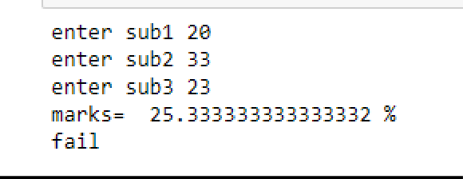

**Task 3:** A spam is defined is if a string has these following keywords

“Make alot of money” “Buy now” “Subscribe this “ “Click this”

## Code:

**a="make alot of money" b="buy now" c="subscribes now" d="click this" email=input("wite mail")**

## if(a in email or b in email or c in email or d in email): print("spam mail")

**else:**

## print("not spam ") Output:

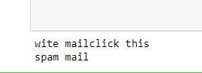

**Task 4:**Write down a program to find weather a give username cotain less then 10 characters

## Code:

**user=input("name") if(len(user)<10):**

## print("True") else:

**print("false") Output:**

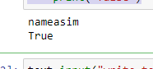

**Task 5:** Write a program to calculate the grade pf students from his marks from following schema. 90---100—Excellent

80---90 A

70---80 B

60---70 C

## Code:

50----60---D

<50 fail

## marks=int(input("enter marks of students ")) if(marks>=90 and marks<=100):

**print("Grade = Excelent") elif(marks>=80 and marks<90):**

## print("Grade = A") elif(marks>=70 and marks<80):

**print("Grade = B") elif(marks>=60 and marks<70):**

## print("Grade = C") elif(marks>=50 and marks<60):

**print("Grade = D") else:**

## print("Student fail") Output:

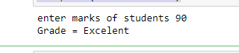

**Conclusion:**In this lab we learned basic of conditional statements of python programming and how to implement them. All the tasks were performed and submitted to the instructor.

# LAB NO. 3 Lists

**Task 1**: Write a program to store seven fruits in list enter by user

## Code:

fruits1=input("enter fruits ") fruits2=input("enter fruits ") fruits3=input("enter fruits ") fruits4=input("enter fruits ") fruits5=input("enter fruits ") fruits6=input("enter fruits ") fruits7=input("enter fruits ")

fruit=[fruits1,fruits2,fruits3,fruits4,fruits5,fruits6,fruits7]

print(fruit)

**Output:**

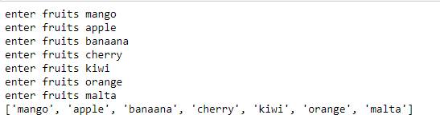

**Task 2:**Write a program to accept marks of student and display them in sorted manner

### Code:

std1=int(input("enter s1 ")) std2=int(input("enter s2 ")) std3=int(input("enter s3 ")) std4=int(input("enter s4 ")) std5=int(input("enter s5 ")) std6=int(input("enter s6 ")) marks=[std1,std2,std3,std4,std5,std6] marks.sort()

print(marks)

**Output:**

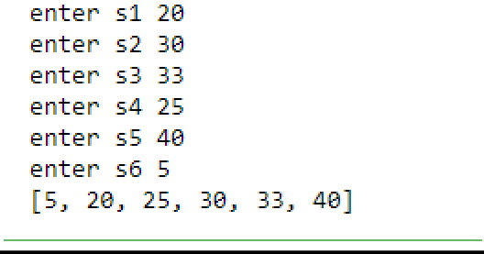

**Task 3:** Write a program to change the tuple(test)

## Code: a=(1,2,3,4)

**a.insert(0,2) Output:**

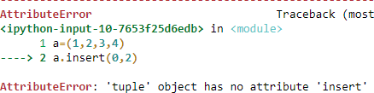

**Task 4:**Write a program to count “0” in following tuple a=(1,0,5,7,8,0,5,0)

## Code:

**a=(1,0,5,7,8,0,5,0)**

## a.count(0) Output:

**Task 5:** Write a program to sum a list of 5 numbers

## Code:

**l=[5,10,10,20,5] sum=l[0]+l[1]+l[2]+l[3]+l[4]**

## print(sum) Output:

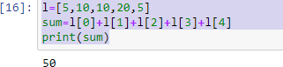

**Conclusion:**

In this lab we learned lists tuples and their methods in python programming and how to implement them. All the tasks were performed and submitted to the instructor.